**Azure availability zones**

You want to ensure your services and data are redundant so you can protect your information in case of failure.

When you host your infrastructure, setting up your own redundancy requires that you create duplicate hardware environments. Azure can help make your app highly available through availability zones.

**What is an availability zone?**

Availability zones are physically separate datacenters within an Azure region.

Each availability zone is made up of one or more datacenters equipped with independent power, cooling, and networking.

An availability zone is set up to be an isolation boundary. If one zone goes down, the other continues working.

Availability zones are connected through high-speed, private fiber-optic networks.

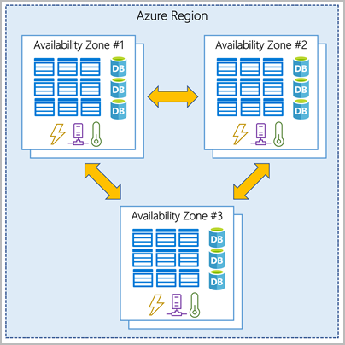

***Note: Not every region has support for availability zones***

**Use availability zones in your apps**

* You can use availability zones to run mission-critical applications and build high-availability into your application
* architecture by co-locating your compute, storage, networking, and data resources within a zone and replicating in other zones.
* Keep in mind that there could be a cost to duplicating your services and transferring data between zones.
* Availability zones are primarily for VMs, managed disks, load balancers, and SQL databases.
* Azure services that support availability zones fall into three categories:
* **Zonal services**: You pin the resource to a specific zone (for example, VMs, managed disks, IP addresses).
* **Zone-redundant services**: The platform replicates automatically across zones (for example, zone-redundant storage, SQL Database).
* **Non-regional services**: Services are always available from Azure geographies and are resilient to zone-wide outages as well as region-wide outages.

**Azure region pairs**

Availability zones are created by using one or more datacenters. There's a minimum of three zones within a single region. It's possible that a large disaster could cause an outage big enough to affect even two datacenters. That's why Azure also creates region pairs.

**What is a region pair?**

* Each Azure region is always paired with another region within the same geography (such as US, Europe, or Asia) at least 300 miles away.
* This approach allows for the replication of resources (such as VM storage) across a geography that helps reduce the likelihood of interruptions because of events such as natural disasters, civil unrest, power outages, or physical network outages that affect both regions at once.
* If a region in a pair was affected by a natural disaster, for instance, services would automatically failover to the other region in its region pair.
* Examples of region pairs in Azure are West US paired with East US and SouthEast Asia paired with East Asia.

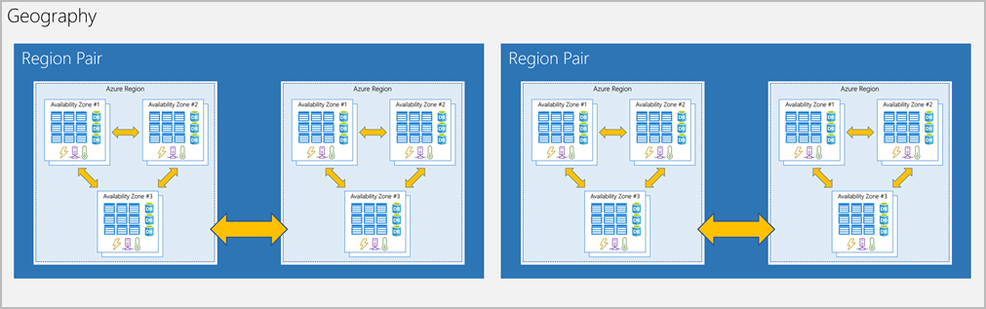

Additional advantages of region pairs:

* If an extensive Azure outage occurs, one region out of every pair is prioritized to make sure at least one is restored as quickly as possible for applications hosted in that region pair.
* Planned Azure updates are rolled out to paired regions one region at a time to minimize downtime and risk of application outage.
* Data continues to reside within the same geography as its pair (except for Brazil South) for tax- and law-enforcement jurisdiction purposes.

Having a broadly distributed set of datacenters allows Azure to provide a high guarantee of availability.